Mother Board and CPU Theory

- Draw a labeled diagram of an ATX motherboard and mark at least 8 different slots and ports (such as RAM slots, PCIe slots, SATA ports, USB headers, CPU socket, power connector, etc.).

Introduction
The motherboard is the main circuit board of a computer. It connects the CPU, RAM, storage devices, graphics card and other hardware so they can communicate efficiently. The ATX (Advanced Technology extended) motherboard is one of the most widely used motherboard form factors in desktop computers. It acts as the main circuit board that connects and allows communication between all the essential hardware components, including the CPU, RAM, storage devices, graphics card, and input/output ports. An ATX motherboard provides multiple expansion slots, memory slots, storage connectors, and power connectors, making it suitable for home, office, and gaming computers. Understanding the layout and functions of its various slots and ports helps in assembling, upgrading, and troubleshooting a computer system effectively.
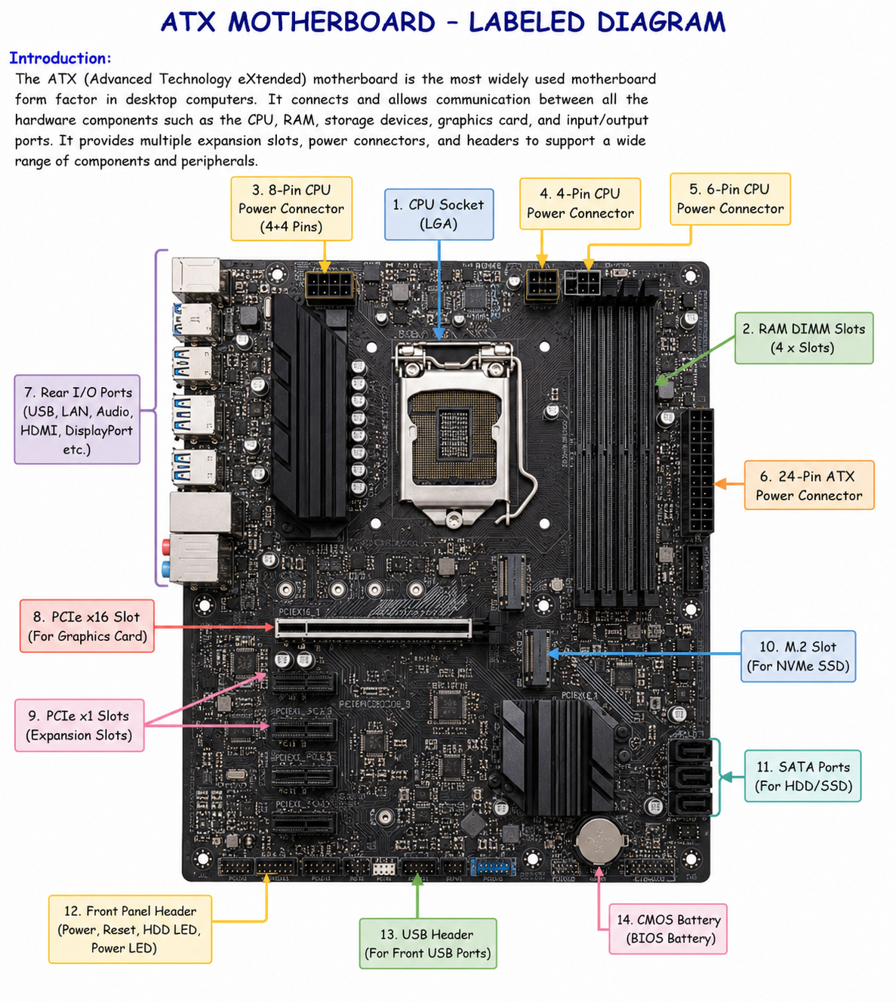

Research and list 3 popular CPU socket types (for example: LGA1151, AM4, LGA1200) and name one compatible CPU model for each.

- Introduction
A CPU socket is a specially designed connector on the motherboard that holds the processor (CPU) and allows it to communicate with other computer components. Different processors require different socket types because they vary in size, pin layout, and electrical connections. Therefore, a CPU can only be installed on a motherboard that supports its specific socket type. Choosing the correct CPU socket is essential for ensuring compatibility between the processor and the motherboard.

1. LGA1151 Socket (Intel)
Overview:
The LGA1151 (Land Grid Array 1151) socket was introduced by Intel for its 6th, 7th, 8th, and selected 9th Generation Core processors. In an LGA socket, the pins are located on the motherboard, while the processor has flat contact pads. It became one of Intel's most widely used sockets for home, office, and gaming computers.
Compatible CPU Model:
- Intel Core i7-9700K
Features:
- Supports DDR4 memory
- Suitable for gaming and productivity
- Supports PCIe expansion cards
- Commonly found in mid-range and high-performance desktop PCs

2. AM4 Socket (AMD)
Overview:
The AM4 socket is one of AMD's most successful desktop CPU sockets. It supports multiple generations of Ryzen processors, making it a popular choice because users can often upgrade their CPU without changing the motherboard. This socket is widely used in gaming PCs, workstations, and home computers.
Compatible CPU Model:
- AMD Ryzen 5 5600X
Features:
- Supports AMD Ryzen processors
- Compatible with DDR4 memory
- Excellent performance for gaming, content creation, and multitasking
- Long upgrade path with support for several CPU generations

3. LGA1200 Socket (Intel)
Overview:
The LGA1200 socket was introduced by Intel for its 10th and 11th Generation Core processors. Compared to LGA1151, it has more electrical contacts, providing better power delivery and improved performance for newer processors.
Compatible CPU Model:
- Intel Core i5-10400
Features:
- Supports DDR4 RAM
- Improved power delivery compared to LGA1151
- Suitable for office work, multimedia, and gaming
- Supports faster storage and expansion technologies

- Conclusion
CPU sockets play a vital role in determining which processor can be installed on a motherboard. LGA1151, AM4, and LGA1200 are three of the most popular desktop socket types, each designed for specific generations of processors. Before purchasing or upgrading a CPU, it is important to check that the motherboard supports the correct socket type to ensure compatibility and optimal system performance.
- Primary Functions of the CPU and the Chipset on a Motherboard and How They Work Together When Opening Spotify

- Introduction
The CPU (Central Processing Unit) and the chipset are two of the most important components of a motherboard. Although they perform different tasks, they work together continuously to ensure that the computer runs smoothly. The CPU is responsible for processing instructions and performing calculations, while the chipset manages communication between the CPU and the other hardware devices connected to the motherboard. Every time you open an application, browse the internet, or play music, both the CPU and chipset work together to complete the task quickly and efficiently.

Functions of the CPU (Central Processing Unit)
The CPU, often called the "brain of the computer," is the component that executes instructions from software and the operating system. It performs calculations, logical operations, and decision-making processes that allow programs to function.
Primary Functions of the CPU
- Executes Instructions: Processes commands received from the operating system and software applications.
- Performs Calculations: Carries out arithmetic and logical operations required by programs.
- Controls Computer Operations: Coordinates the activities of different hardware components.
- Processes Data: Converts raw data into useful information.
- Multitasking: Handles multiple applications running at the same time using multiple cores and threads.
- Communicates with Memory: Retrieves data from RAM and sends processed data back when needed.
Example
When you click on an application, the CPU reads the instructions required to launch the program, processes those instructions, and tells other components what actions to perform.

Functions of the Chipset
The chipset is a group of electronic controllers on the motherboard that manages communication between the CPU and all other hardware components. It acts like a traffic controller, making sure that data flows correctly between devices without delays or conflicts.
Primary Functions of the Chipset
- Manages Communication: Connects the CPU with RAM, storage devices, graphics cards, USB ports, and other peripherals.
- Controls Data Transfer: Ensures that information moves efficiently between different hardware components.
- Supports Expansion Devices: Manages PCIe slots used for graphics cards, Wi-Fi cards, and other expansion cards.
- Controls Storage Devices: Handles communication with SSDs, HDDs, and SATA devices.
- Manages USB and Other Ports: Enables the CPU to communicate with keyboards, mice, printers, and external storage devices.
- Provides Hardware Compatibility: Allows the motherboard to support different processors, memory, and expansion technologies.

How the CPU and Chipset Work Together When You Open Spotify
When you open a music application like Spotify, several steps take place inside the computer. Both the CPU and the chipset play different but equally important roles.
Step 1: User Clicks the Spotify Icon
You click the Spotify icon using the mouse. The mouse sends this input through the USB port to the motherboard.
Role of the Chipset:
The chipset receives the input from the USB controller and forwards the request to the CPU.

Step 2: CPU Processes the Request
The CPU receives the instruction to open Spotify. It begins executing the program instructions needed to start the application.
Role of the CPU:
- Reads Spotify's executable file.
- Processes the operating system's commands.
- Decides which resources are required.

Step 3: Loading Files from Storage
Spotify's program files are stored on the SSD or HDD.
Role of the Chipset:
The chipset transfers the required data from the SSD or HDD to the system's RAM.

Step 4: Loading into RAM
The program files are copied into RAM because RAM is much faster than storage.
Role of the CPU:
The CPU reads the data from RAM and begins executing Spotify's instructions.

Step 5: Spotify Opens
The Spotify window appears on the screen.
Role of the CPU:
- Processes the application's interface.
- Handles user interactions.
- Manages background processes.
Role of the Chipset:
Transfers display data to the graphics hardware so the interface appears on your monitor.

Step 6: Playing Music
When you select a song and press Play, Spotify retrieves the audio data.
CPU Responsibilities
- Decodes and processes the digital audio stream.
- Manages playback controls such as Play, Pause, Next, and Volume.
- Handles networking tasks required to stream music.
Chipset Responsibilities
- Transfers audio data between the SSD (or internet connection), RAM, CPU, and audio controller.
- Sends the processed audio signal to the speakers or headphones through the audio hardware.

Working Together – Simple Explanation
The CPU and chipset function as a team.
- The CPU acts like the brain, making decisions and processing instructions.
- The chipset acts like a communication manager, ensuring that information moves smoothly between all hardware components.
Without the CPU, the computer cannot process instructions. Without the chipset, the CPU would not be able to communicate efficiently with RAM, storage devices, USB ports, or other hardware.

Flow of Events When Opening Spotify
Click Spotify Icon
│
▼
Mouse Sends Input
│
▼
Chipset Receives Input
│
▼
CPU Processes Request
│
▼
Chipset Loads Spotify Files
from SSD/HDD to RAM
│
▼
CPU Executes Program
│
▼
Spotify Opens
│
▼
Music Plays Through Audio Hardware

- Conclusion
The CPU and the chipset are essential components of a motherboard that work together to perform every task on a computer. The CPU processes instructions, performs calculations, and controls the execution of programs, while the chipset manages communication between the CPU and all other hardware devices. When you open Spotify, the chipset transfers the required data from storage to RAM, and the CPU processes that data to launch the application and play music. Their coordinated operation ensures that applications run quickly, smoothly, and efficiently.

- Find a clear photo of a real motherboard (from the internet or your own device), and identify at least 5 different ports or slots by circling them and labeling each one.

- Introduction

A motherboard contains several ports, slots, and connectors that allow different hardware components to communicate with each other. By identifying these components on a real motherboard, we can better understand how a computer is assembled and how each part contributes to the overall functioning of the system. In the motherboard image below, the important ports and slots have been circled and labeled for easy identification.
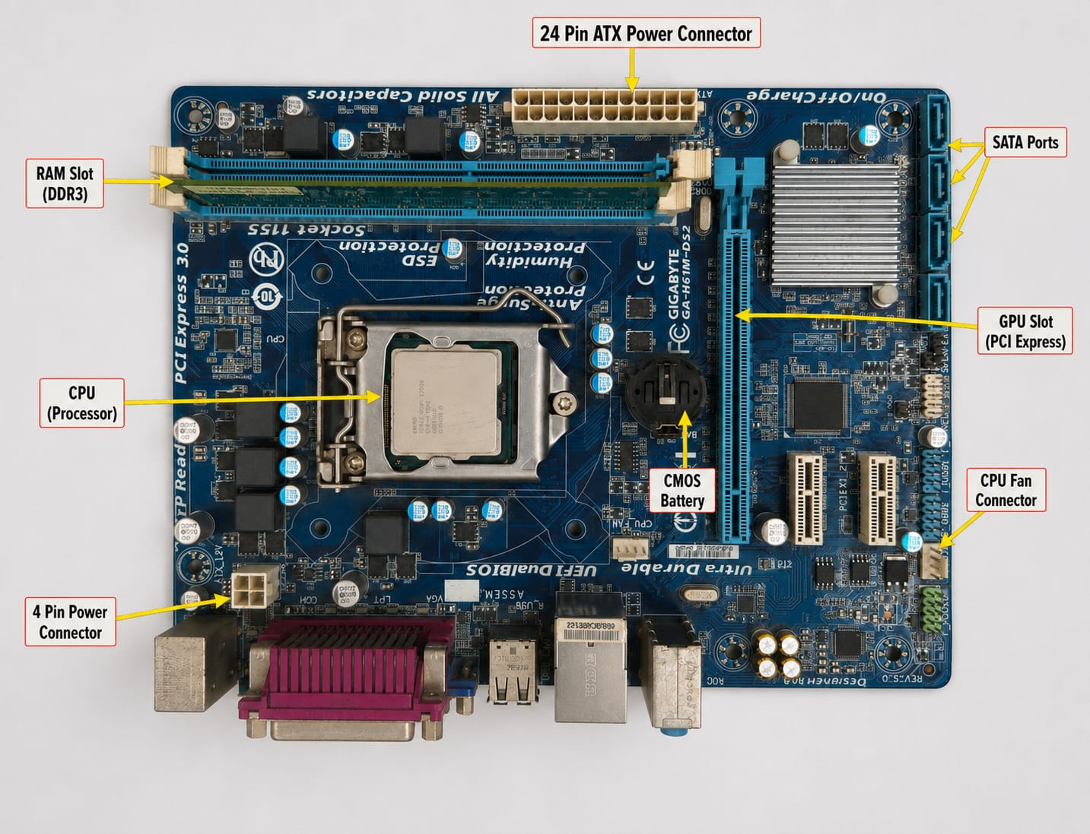

Identified Ports and Slots
1. CPU Socket
The CPU socket is the location where the processor (CPU) is installed. It provides the electrical connections between the CPU and the motherboard, allowing the processor to communicate with all other hardware components. Every motherboard supports only specific CPU socket types, so choosing a compatible processor is essential.
Function: Holds the processor and enables communication between the CPU and the motherboard.

2. RAM (DIMM) Slots
The RAM (Random Access Memory) slots, also called DIMM slots, are used to install memory modules. RAM temporarily stores the data and instructions that the CPU needs while programs are running. Most ATX motherboards have two or four DIMM slots to support multiple memory modules.
Function: Holds RAM modules and provides temporary storage for active programs and data.

3. PCIe x16 Slot
The PCI Express (PCIe) x16 slot is the largest expansion slot on the motherboard. It is mainly used to install a dedicated graphics card (GPU), although other high-speed expansion cards can also use this slot.
Function: Connects high-performance expansion cards, especially graphics cards.

4. SATA Ports
SATA (Serial ATA) ports are connectors used to attach storage devices such as Hard Disk Drives (HDDs), Solid State Drives (SSDs), and optical drives. Data cables connect these devices to the motherboard through the SATA ports.
Function: Connects internal storage devices to the motherboard for data transfer.

5. 24-Pin ATX Power Connector
The 24-pin ATX power connector is the motherboard's main power connection. It receives electrical power from the power supply unit (PSU) and distributes it to the motherboard and many connected components.
Function: Supplies the main electrical power required for the motherboard to operate.

6. Rear I/O Ports (Optional Identification)
The Rear Input/Output (I/O) ports are located on the back edge of the motherboard. They include USB ports, HDMI or DisplayPort, Ethernet (LAN), audio jacks, and sometimes PS/2 ports. These ports allow users to connect external devices.
Function: Connects external devices such as keyboards, mice, monitors, speakers, printers, and network cables.

7. M.2 Slot (Optional Identification)
The M.2 slot is designed for installing high-speed NVMe or SATA SSDs. M.2 SSDs provide much faster data transfer speeds than traditional SATA drives.
Function: Allows installation of high-speed solid-state storage devices.

Summary Table
Port/Slot | Purpose
CPU Socket | Holds the processor and connects it to the motherboard.
RAM (DIMM) Slots | Install RAM modules for temporary memory storage.
PCIe x16 Slot | Used to install a graphics card or other high-speed expansion cards.
SATA Ports | Connect HDDs, SSDs, and optical drives.
24-Pin ATX Power Connector | Supplies main power to the motherboard.
Rear I/O Ports | Connect external devices such as USB devices, monitor, keyboard, mouse, and LAN cable.
M.2 Slot | Installs high-speed NVMe or SATA SSDs.

- Conclusion

By examining and labeling a real motherboard, it becomes easier to understand the purpose of its various ports and slots. Components such as the CPU socket, RAM slots, PCIe slot, SATA ports, and the 24-pin ATX power connector each perform a specific role in the operation of a computer. Identifying these parts improves our knowledge of computer hardware, making it easier to assemble, upgrade, and troubleshoot desktop systems.

